**1.What is RMI ?**

The **RMI** (Remote Method Invocation) is an API that provides a mechanism to create distributed application in java. The RMI allows an object to invoke methods on an object running in another JVM.

The RMI provides remote communication between the applications using two objects *stub* and *skeleton*.

The stub is an object, acts as a gateway for the client side. All the outgoing requests are routed through it. It resides at the client side and represents the remote object. It initiates a connection with remote Virtual Machine (JVM),

1. It writes and transmits (marshals) the parameters to the remote Virtual Machine (JVM),
2. It reads (unmarshals) the return value or exception, and
3. It finally, returns the value to the caller.
4. It initiates a connection with remote Virtual Machine (JVM),

The skeleton is an object, acts as a gateway for the server side object. All the incoming requests are routed through it

1. t reads the parameter for the remote method
2. It invokes the method on the actual remote object, and
3. It writes and transmits (marshals) the result to the caller.

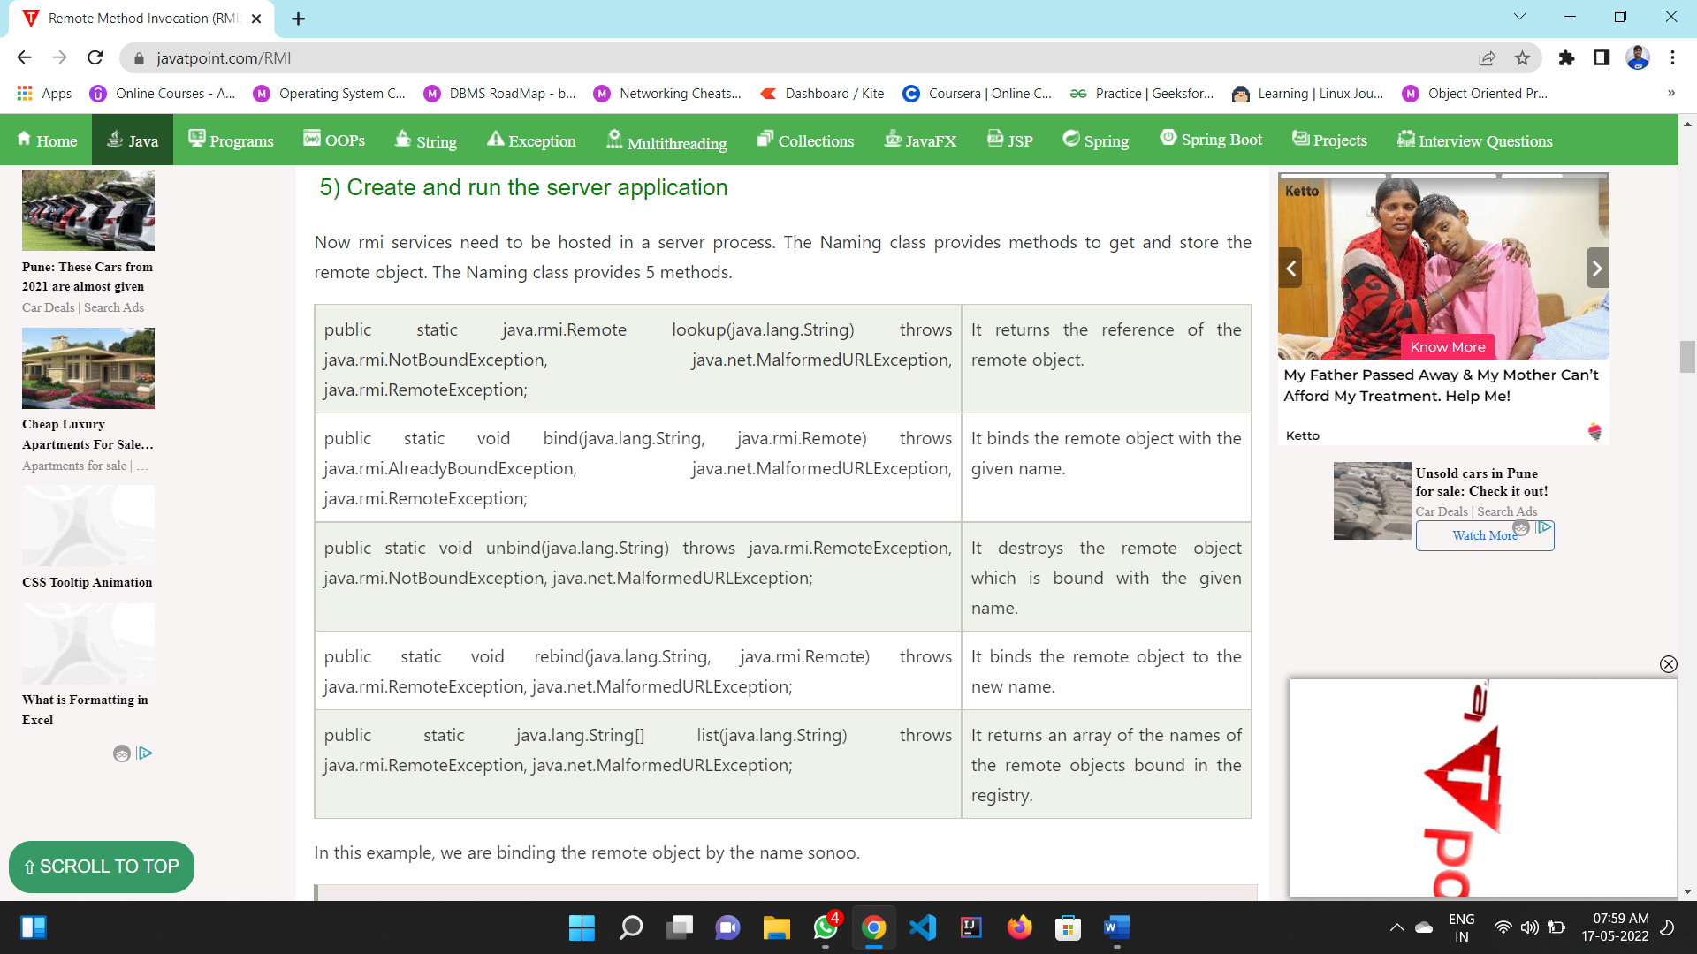Next step is to create stub and skeleton objects using the rmi compiler. The rmic tool invokes the RMI compiler and creates stub and skeleton objects.

<https://www.javatpoint.com/RMI>

2.**WHAT IS MEANT BY RPC?**

**Remote Procedure Call (RPC)** is a powerful technique for constructing **distributed, client-server based applications**. It is based on extending the conventional local procedure calling so that the **called procedure need not exist in the same address space as the calling procedure**. The two processes may be on the same system, or they may be on different systems with a network connecting them.

RPC and RMI both are similar but the basic difference between RPC and RMI is that RPC supports procedural programming, on the other hand, RMI supports object-oriented programming.

**3.What is meant by Ditributed System?**

A distributed system, also known as distributed computing, is a system with multiple components located on different machines that communicate and coordinate actions in order to appear as a single coherent system to the end-user.

* **Advantages :**

1. Horizontal Scalability: it is easy and generally inexpensive to add additional nodes and functionality as necessary.
2. Reliability because fault tolerant systems are made
3. Performance

* **Disadvantages :**

1. Latency
2. Scheduling

**4.What is Replication?**

* In a distributed system data is stored is over different computers in a network. Therefore, we need to make sure that data is readily available for the users. **Availability** of the data is an important factor often accomplished by data replication. ***Replication is the practice of keeping several copies of data in different places***

**Active Replication:**

* The request of the client goes to all the replicas.

### Passive Replication:

* The client request goes to the primary replica, also called the main replica.
* There are more replicas that act as backup for the primary replica.

**5.What is GLOBAL NAME SERVICES?**

* A global naming service identifies (names) those enterprise-level networks around the world that are linked together via phone, satellite, or other communication systems.
* The GNS manages a naming database that is composed of a tree of directories holding names and values

**6.What is the disadvantage of Existing Naming Service?**

One of the main disadvantages of the DNS is the fact that its registry can only be controlled BY ICANN, a non-profit organisation with roots tied in one country.

**7.What is meant by Zone ?**

A DNS zone is a **part of the DNS namespace that is administered by a specific organization or person**. In this sense, a DNS zone can be looked at as an administrative unit; it is neither the same as the term domain nor a specific name server. A DNS zone comprises at least one domain and, if applicable, further subdomains. However, subdomains can also be implemented as separate zones.

**8.What is a file group?**

* **The filegroup contains the primary data file and any secondary files that aren't put into other filegroups.**
* **User-defined filegroups can be created to group data files together for administrative, data allocation, and placement purposes.** Database filegroups consist of files and database objects (tables, indexes, stored procedures, etc).

**9.What are the Major Goals of the Sun NFS?**

**In NFSv2, the main goal in the design of the protocol was simple and fast server crash recovery.**

This simple goal is realized in NFSv2 by designing what we refer to as a stateless protocol. The server, by design, does not keep track of anything about what is happening at each client. For example, the server does not know which clients are caching which blocks, or which files are currently open at each client, or the current file pointer position for a file, etc. Simply put, the server does not track anything about what clients are doing; rather, the protocol is designed to deliver in each protocol request all the information that is needed in order to complete the request

**10.Whaat are the two types of HTTP Messages?**

**Requests sent by the client to trigger an action on the server, and responses, the answer from the server.**

**11.What are the principles of webservices?**

* Available over the internet or intranet networks.
* Standardized XML messaging system.
* Independent of a single operating system or programming language.
* Self-describing via standard XML language.
* Discoverable through a simple location method.
* Web services use XML at data representation and data transportation layers. ...

**12.List and explain various types of failure in communicatiors**

**: transaction failures (aborts), site (system) failures, media (disk) failures, and communication line failures**

**13.Write a short note fault tolerant?**

Fault tolerance is a process that enables an operating system to respond to a failure in hardware or software. This fault-tolerance definition refers to the system’s ability to continue operating despite failures or malfunctions .Fault tolerance can be built into a system to remove the risk of it having a single point of failure. Replication is a more complex approach to achieving fault tolerance. It involves using multiple identical versions of systems and subsystems and ensuring their functions always provide identical results.

**15.Reading and writing from fileservers**

**20.what is gossip architecture.**

**The gossip architecture is a framework for providing a highly available service which replicates data close to the points where groups of clients request it.**

**TCP SOCKET PROGRAMMING**

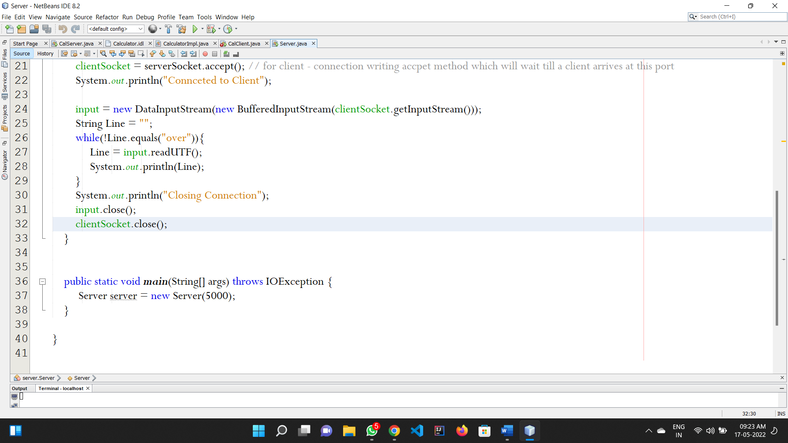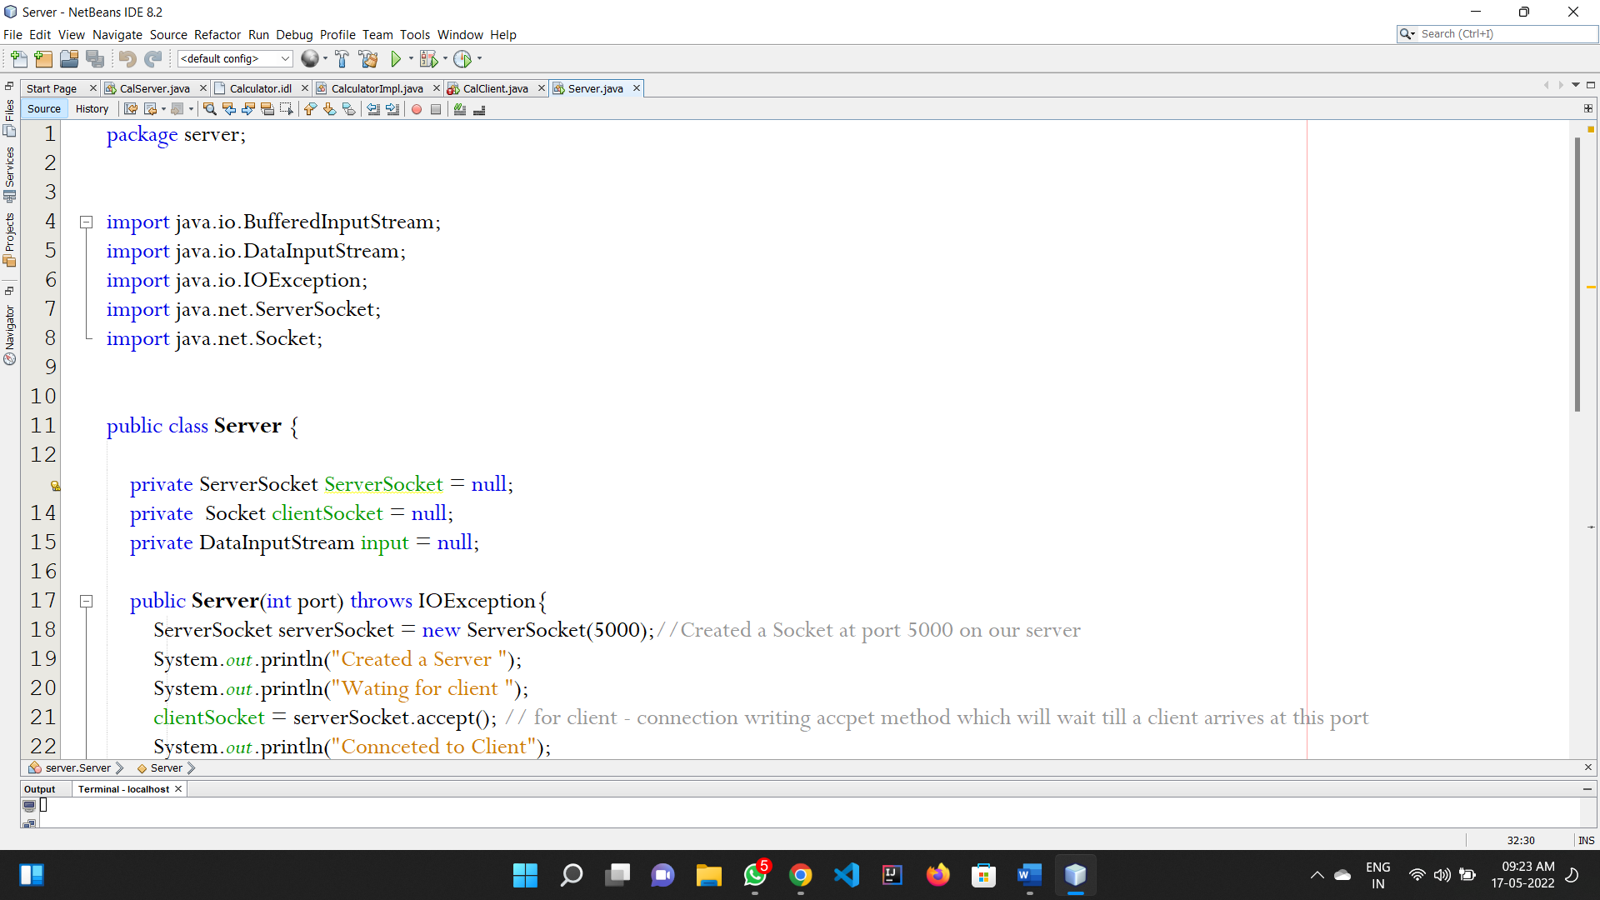**SERVER.JAVA**

**CLIENT.java**

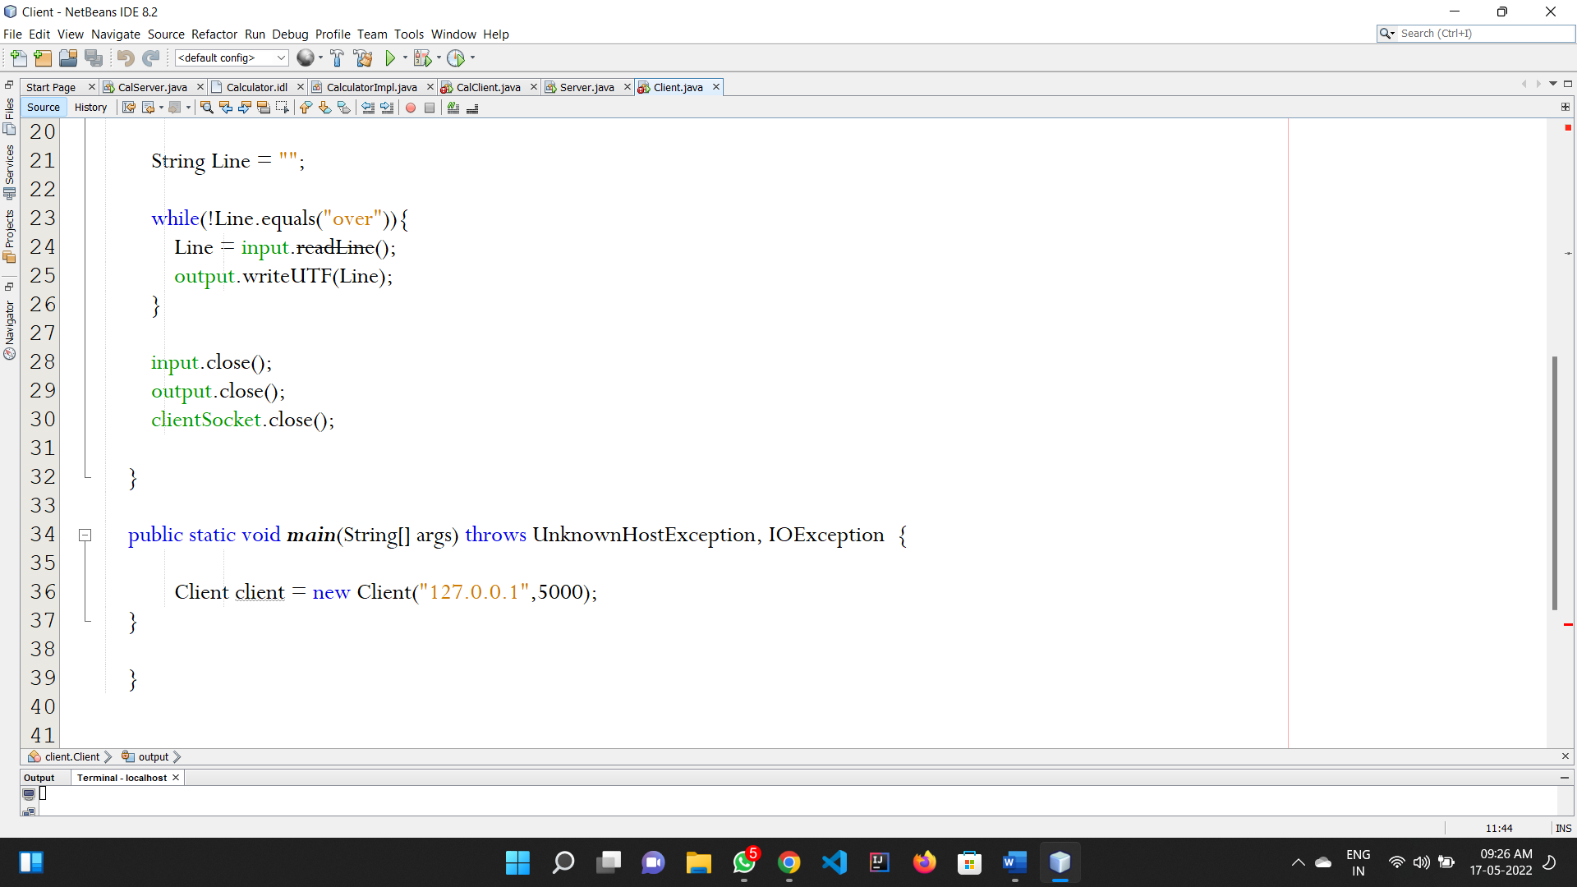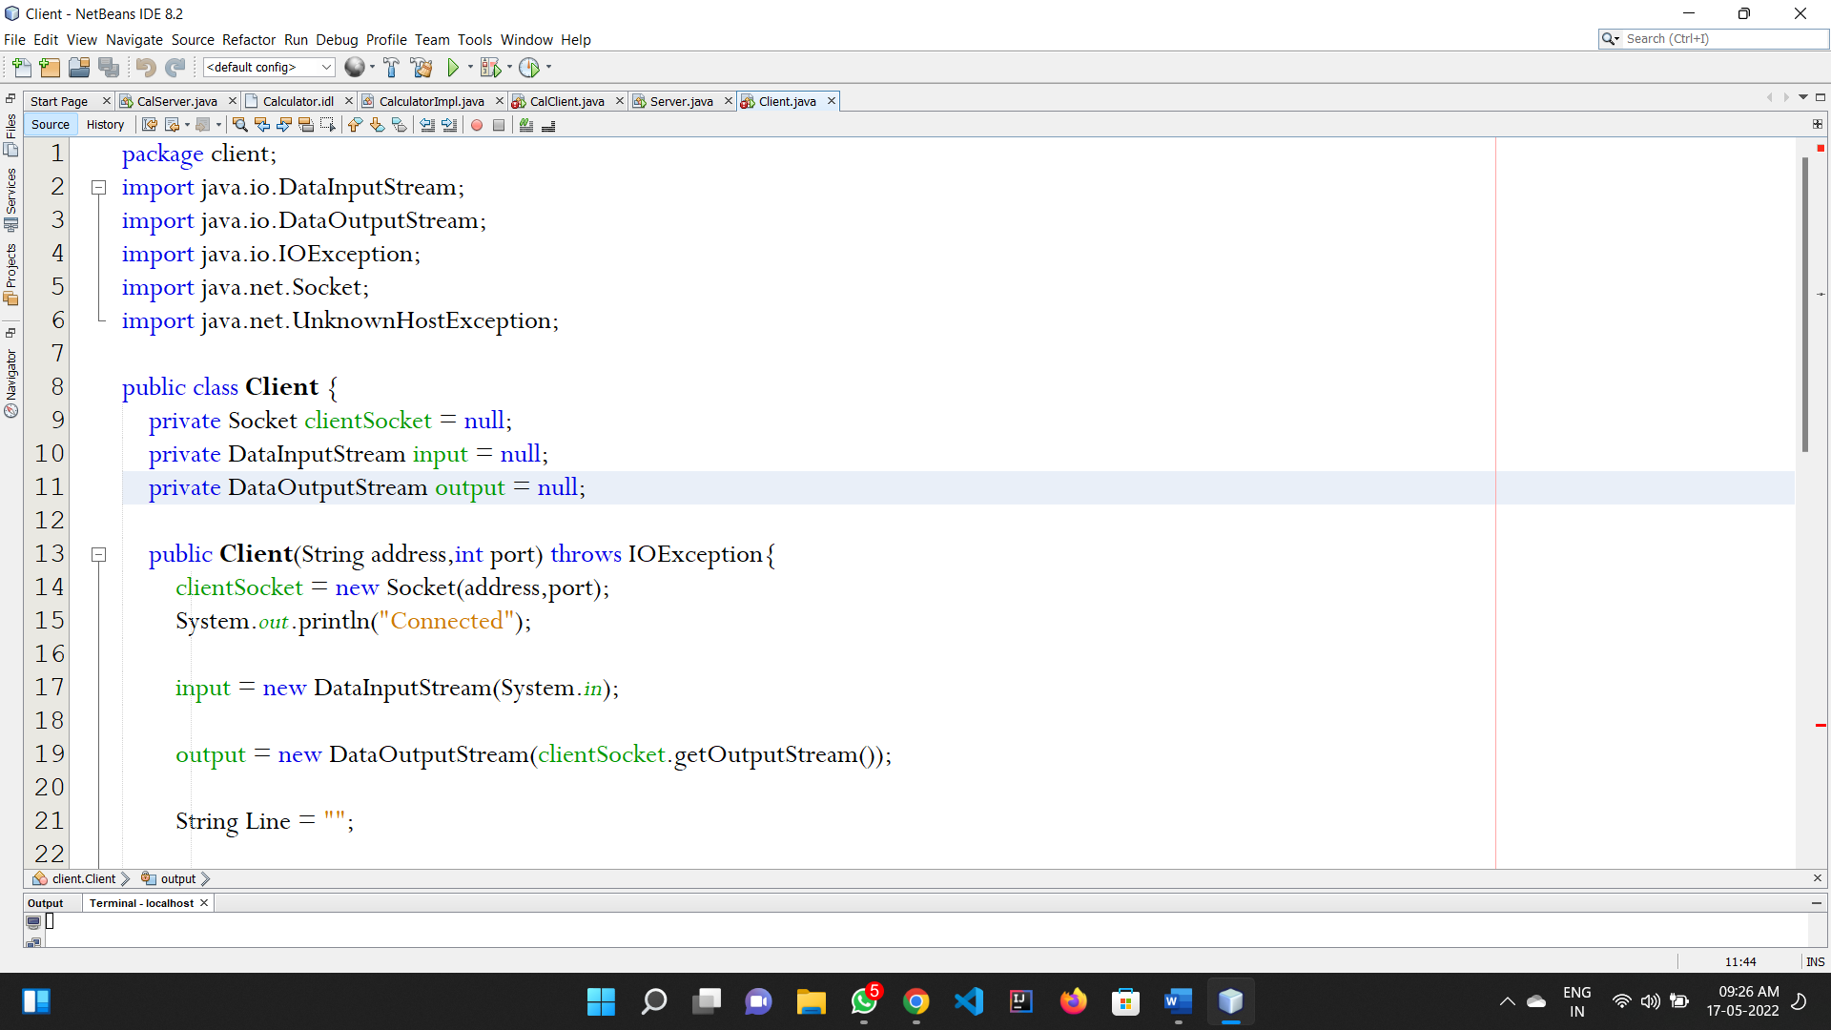

**UPD SOCKET PROGRAMMING**

**SIMPLE VERSION**

**Server.java**

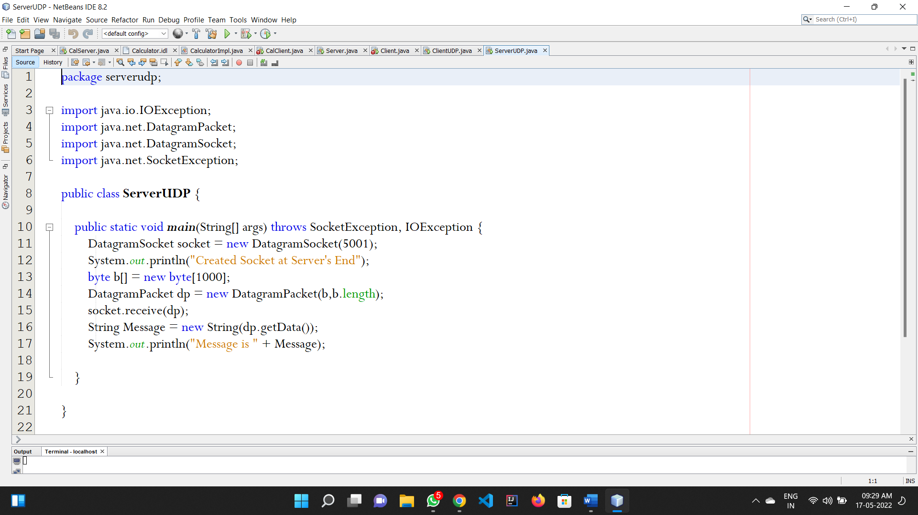

**Client.java**

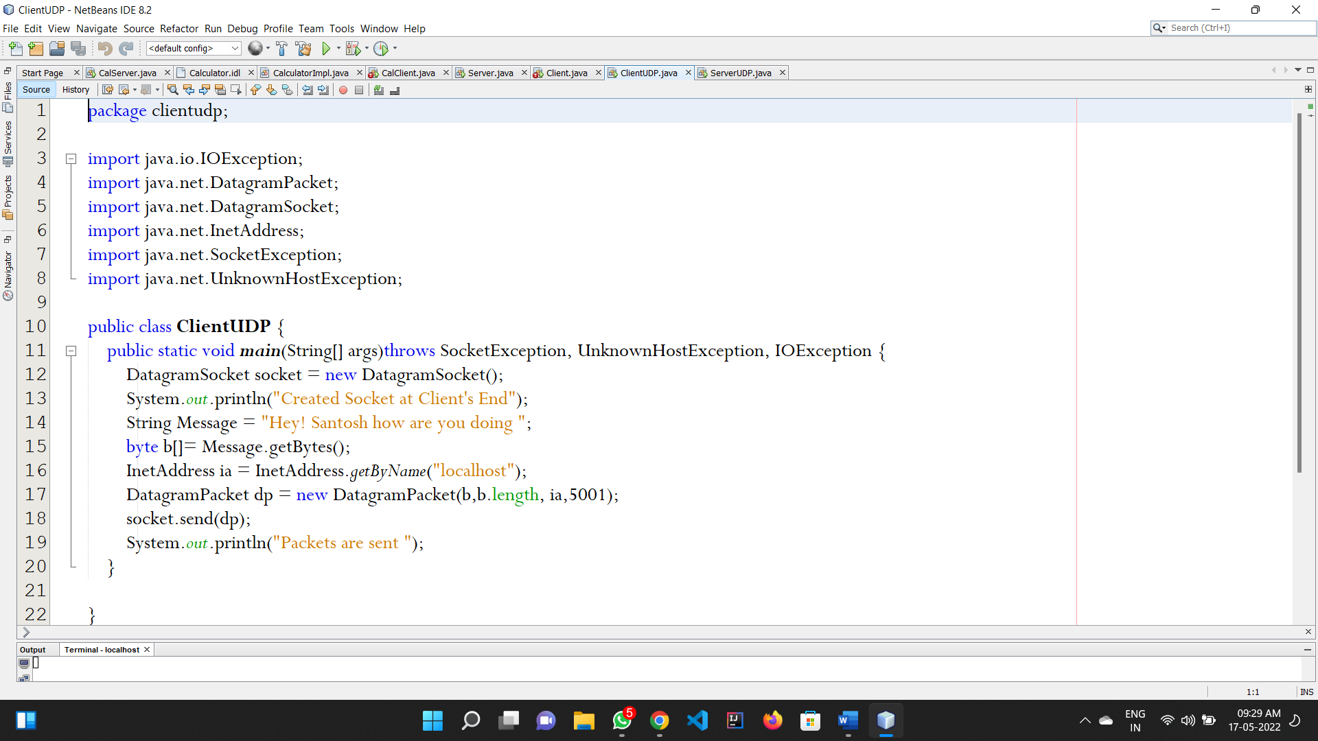

**FILE READING VERISON**

**SERVER.java**

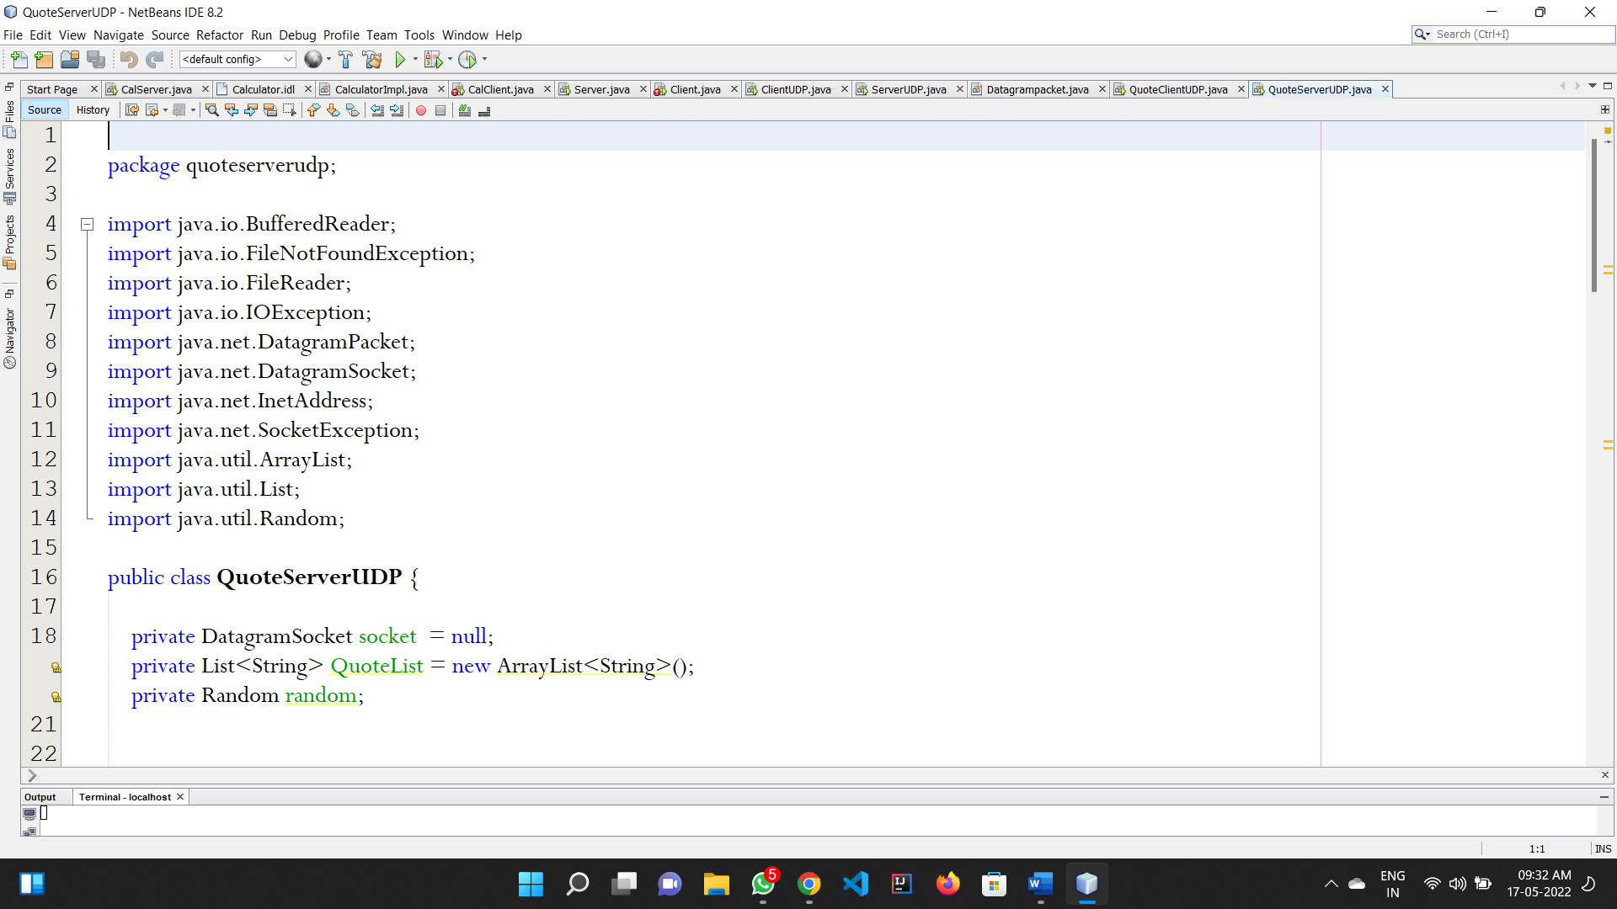

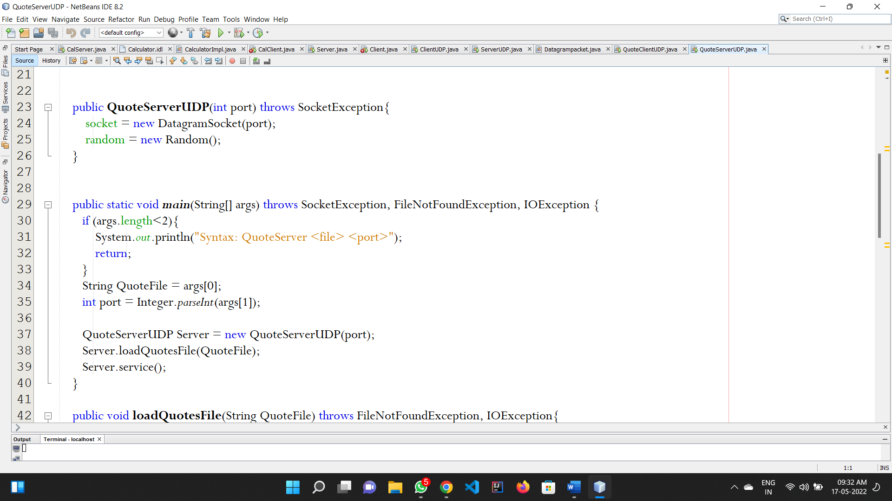

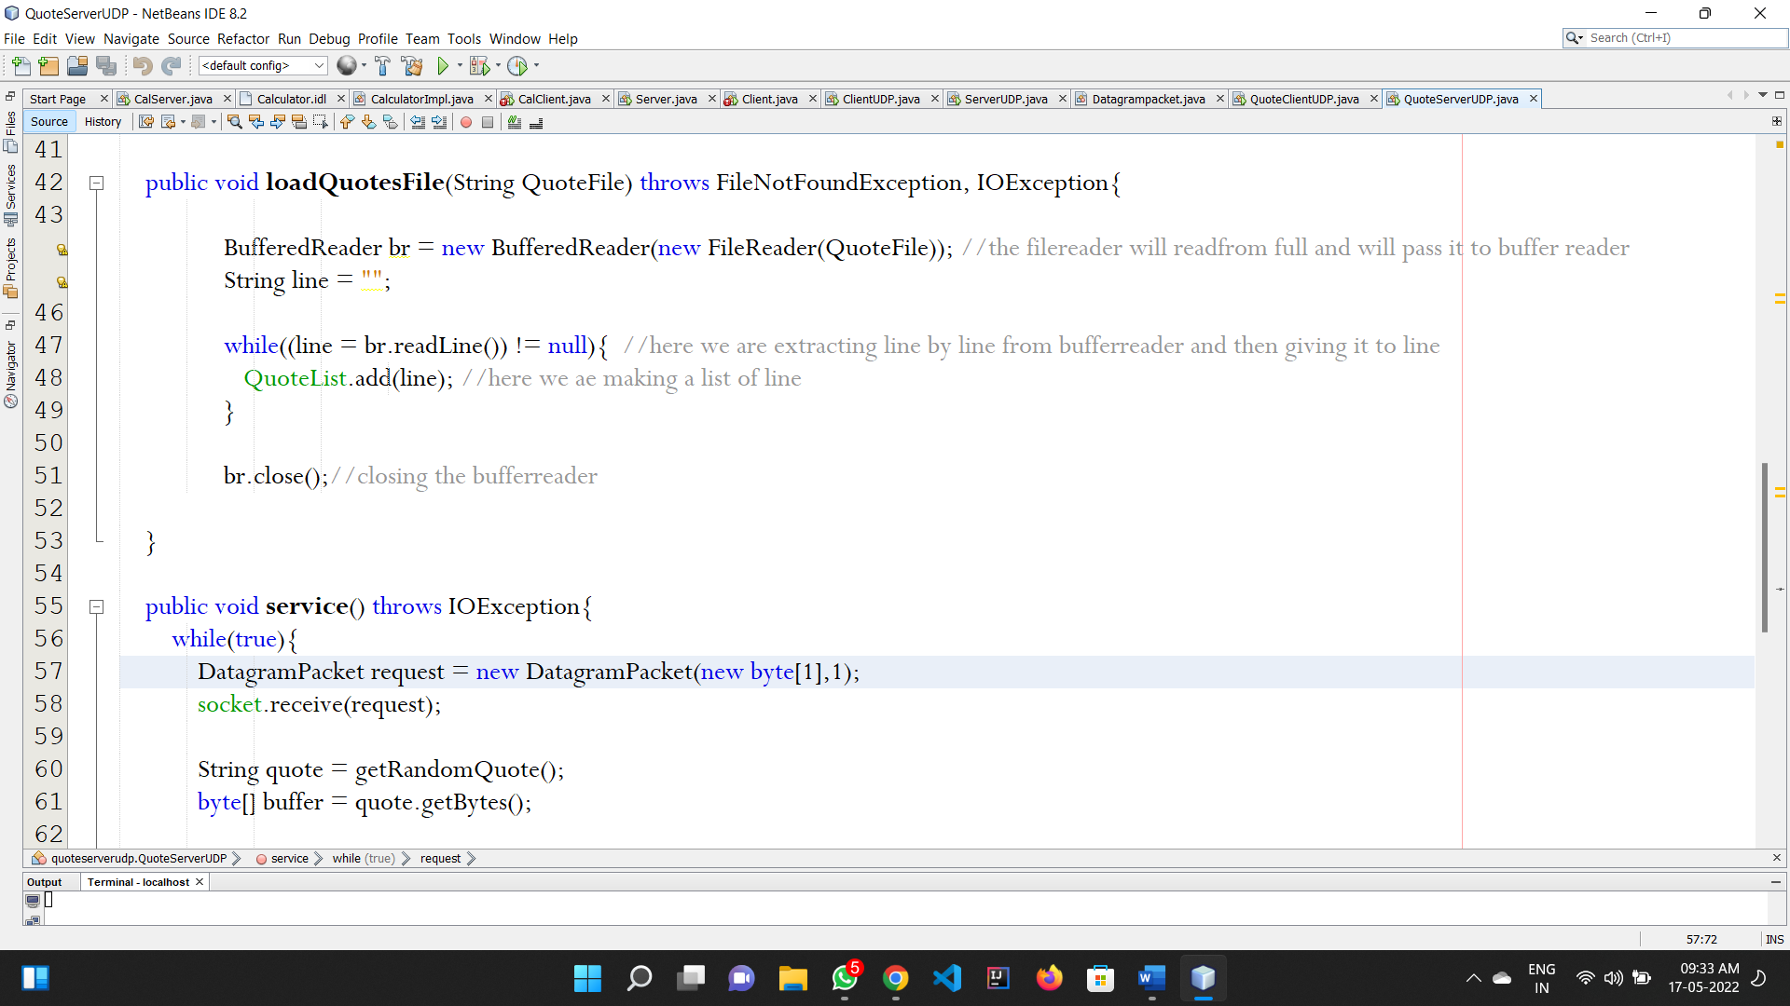

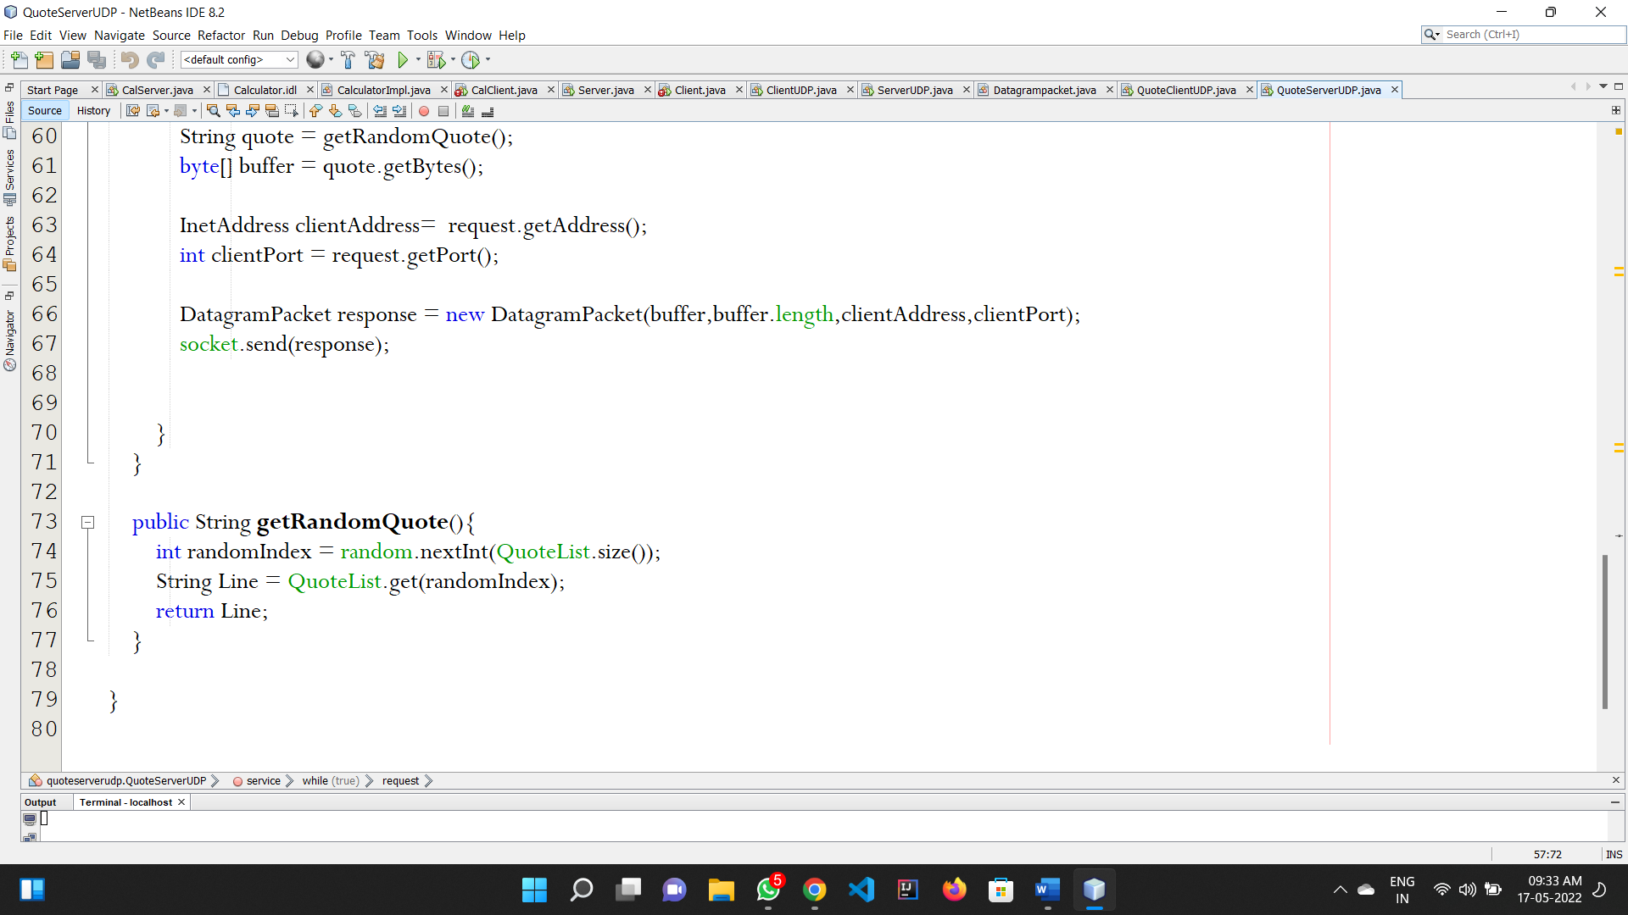

**CLIENT.java**

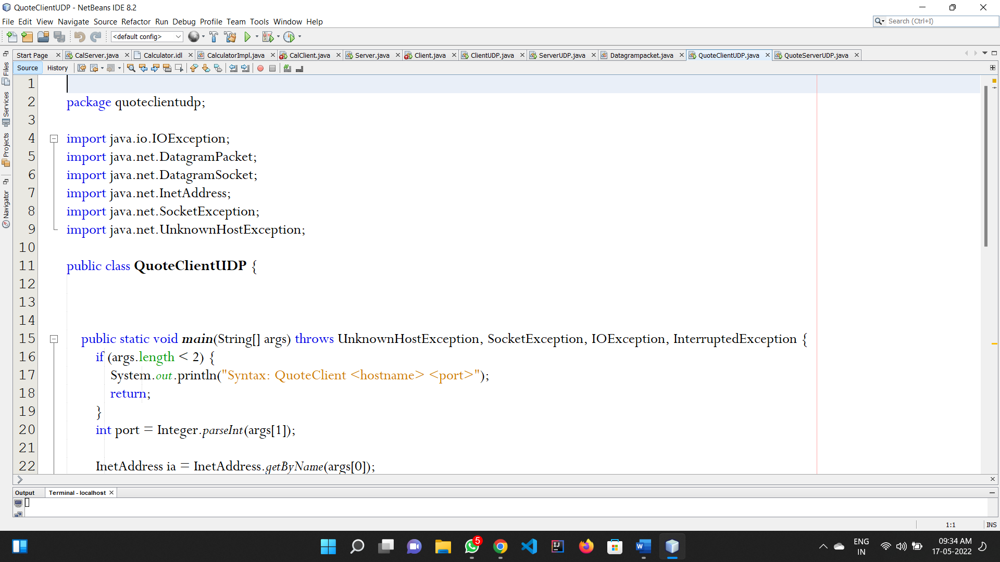

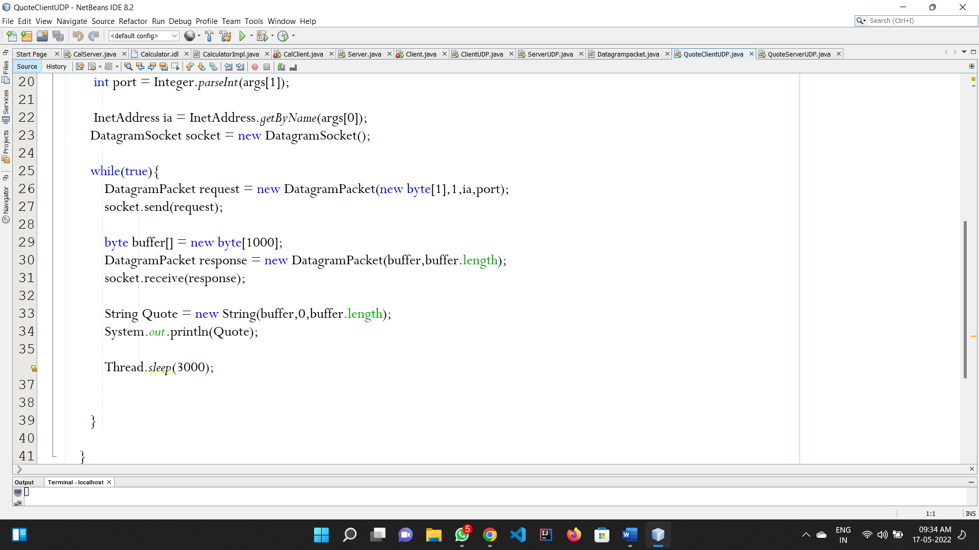

**RMI PROGRAMMING  
ADDERINTERFACE**

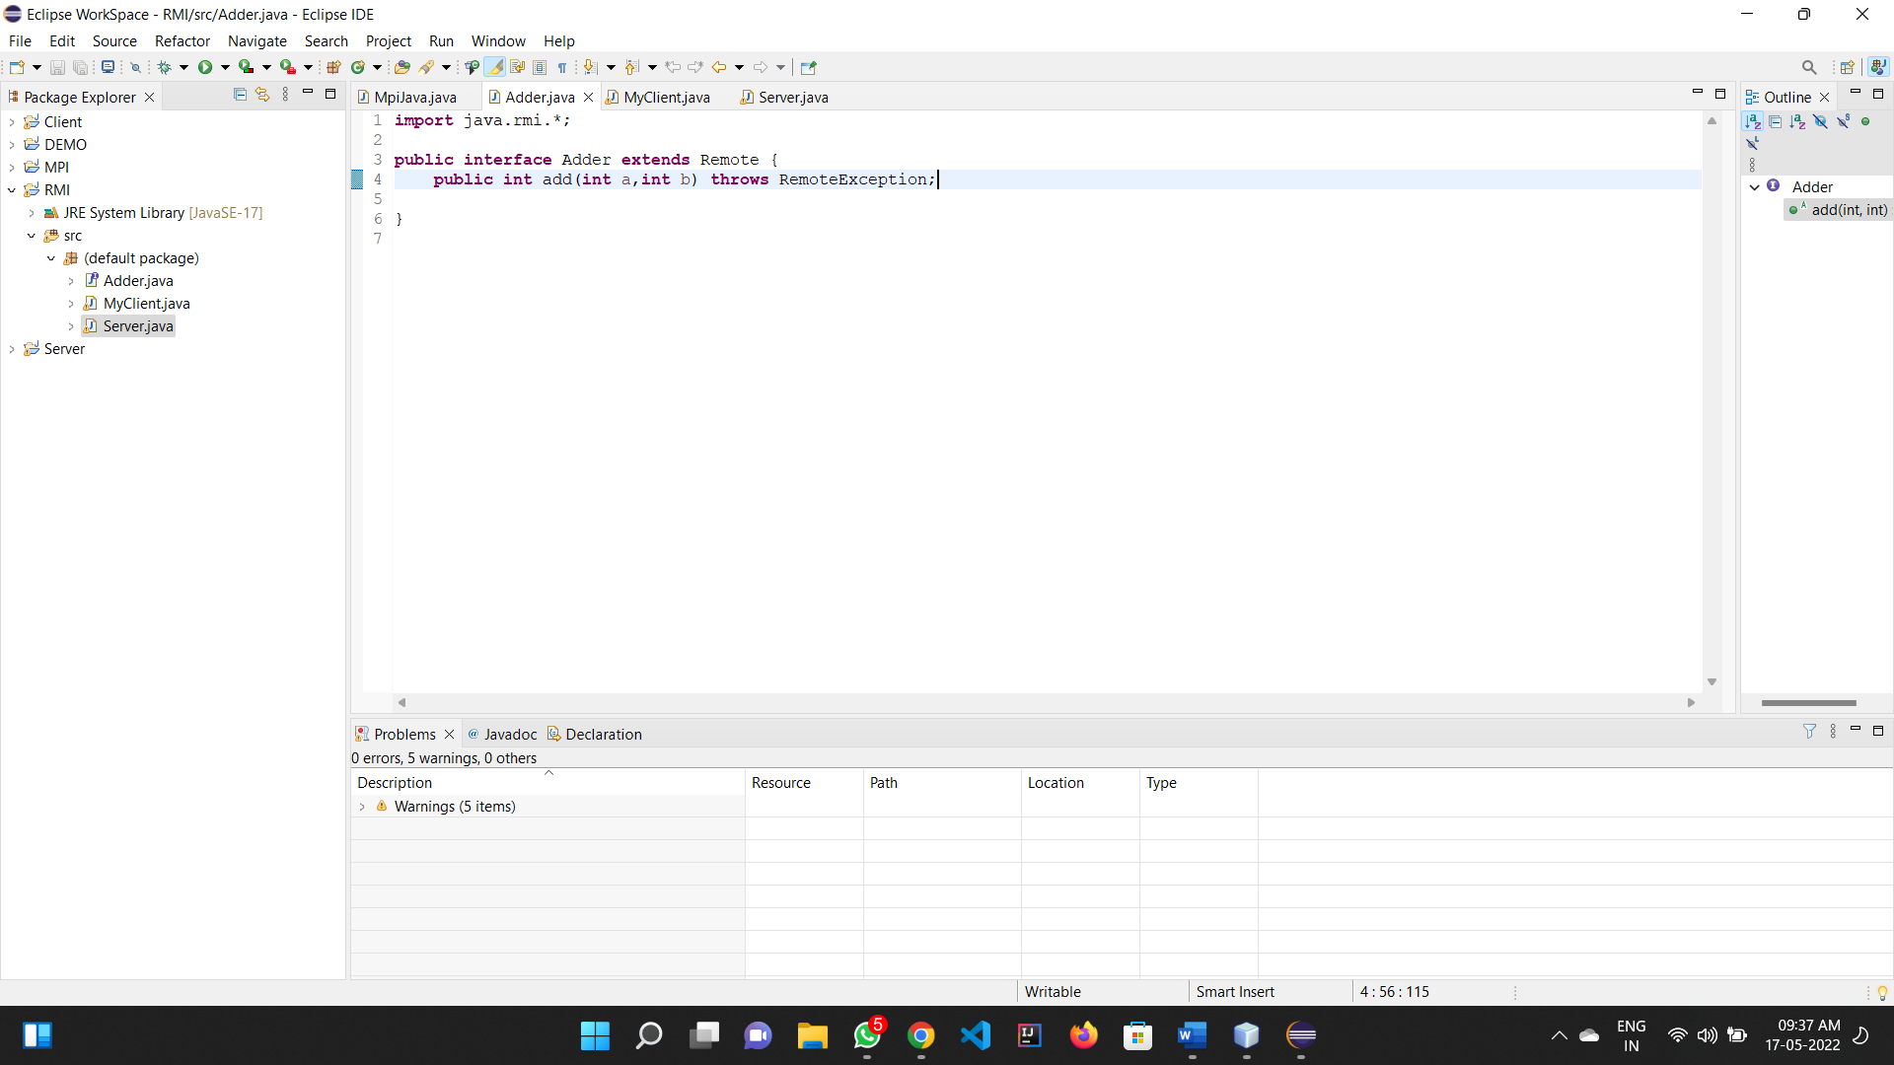

**ADDSERVER.java**

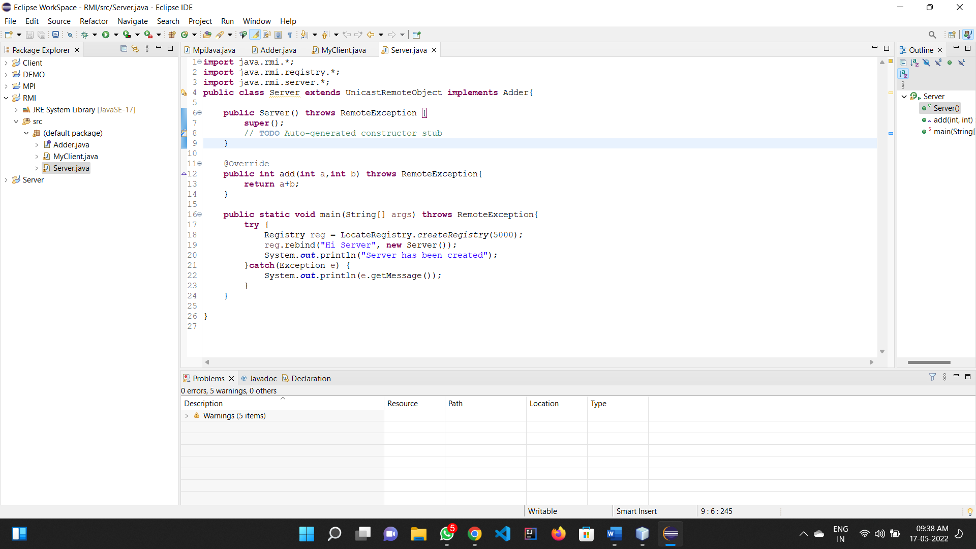

**Client.java**

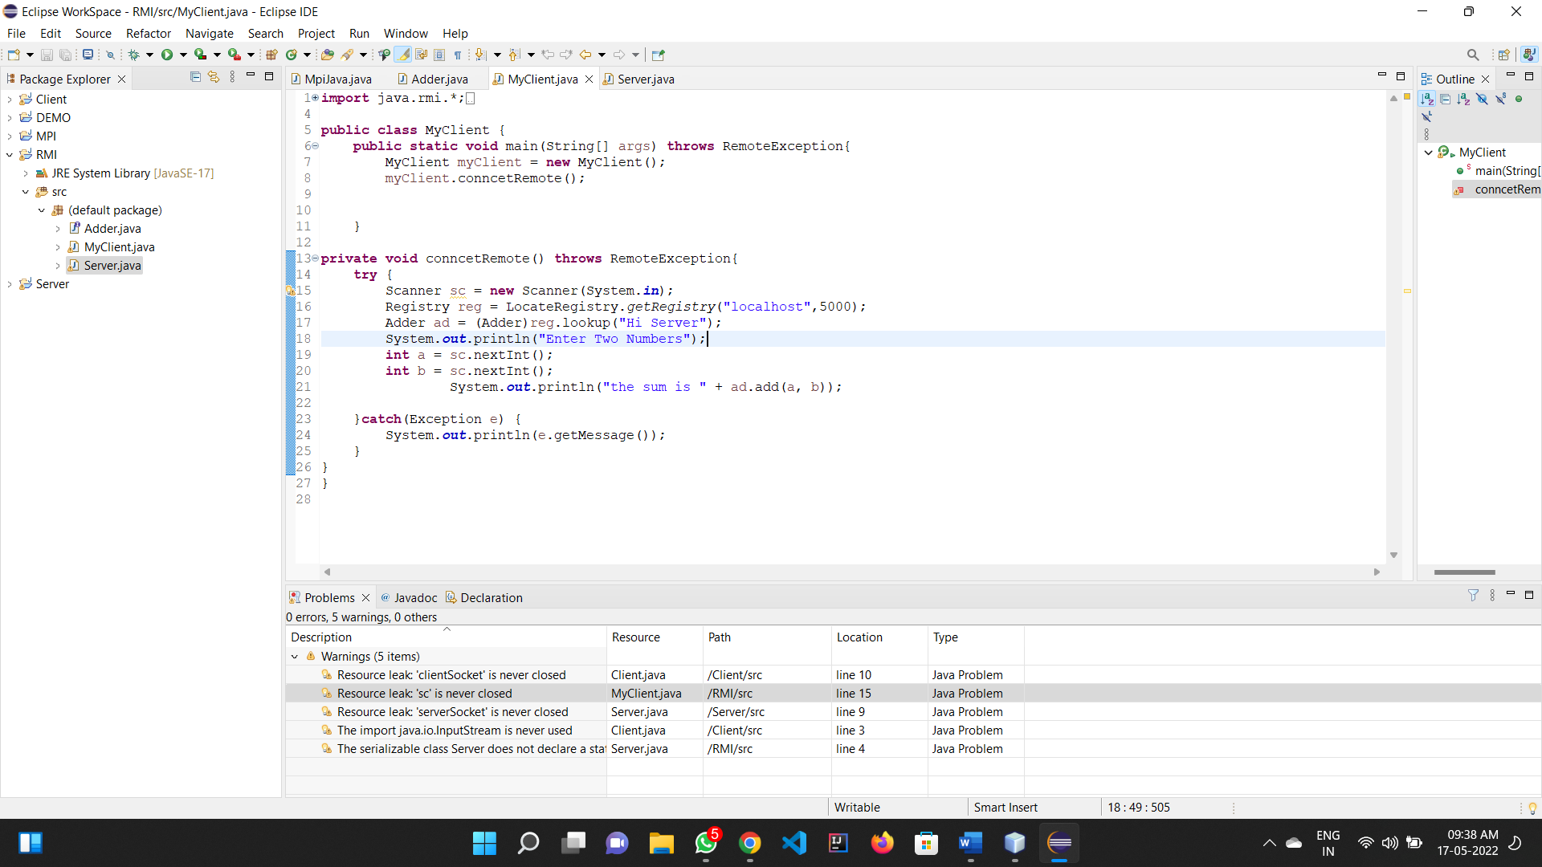

**MPI PROGRAMMING**

